<INTRODUCTION TO DATA MANAGEMENT>
PROJECT REPORT
(Project Semester January-April 2025)

(Indian Unicorn Startups 2023 : Overview )

Submitted by

(Priyanshu Sharma)

Registration No: 12311900

Programme and Section: Computer Science & Engineering, K23PM

Course Code: INT217

Under the Guidance of

(Maneet Kaur, UID;15709 )

Discipline of CSE/IT

Lovely School of Computer Science & Engineering

Lovely Professional University, Phagwara
CERTIFICATE

This is to certify that “Priyanshu Sharma” bearing Registration no. .12311900. has completed .INT217. project titled, “ Indian Unicorn Startups till 2023.” under my guidance and supervision. To the best of my knowledge, the present work is the result of his/her original development, effort and study.

Signature and Name of the Supervisor
Maneet Kaur , UID:15709
Designation of the Supervisor
School of Computer Science and Engineering
Lovely Professional University
Phagwara, Punjab.

Date: 12/April/2025

DECLARATION

I, Priyanshu Sharma, student of Data Science under CSE/IT Discipline at, Lovely Professional University, Punjab, hereby declare that all the information furnished in this project report is based on my own intensive work and is genuine.

Date: 12-04-2025 Signature:
Registration No. 12311900 Priyanshu Sharma

ACKNOWLEDGEMENT

I would like to express my sincere gratitude to Maneet Kaur ma’am for her unwavering support and guidance in my journey of learning data management and mastering Excel. Her expert insights and patience in teaching have truly enhanced my skills, enabling me to create highly visualized dashboards and better understand the power of data analytics.
Through her guidance, I have not only learned the intricacies of Excel but have also gained a deeper appreciation for how effective data management can lead to insightful decision-making. Her ability to simplify complex concepts and her commitment to my growth have been invaluable.
Thank you for being such an inspiring mentor. Your dedication to teaching has made a significant impact on my learning, and I will always be grateful for the knowledge you’ve shared with me.

Warm regards,
Priyanshu Sharma

TABLE OF CONTENT:

1. Introduction
2. Source of the Dataset
3. Dataset Preprocessing
4. Analysis on Dataset (for each objective)
i. General Description
ii. Specific Requirements
iii. Analysis Results
iv. Visualization
5. Conclusion
6. Future Scope
7. References
8. Links

1.Introduction

In recent years, India has emerged as a global hub for startups, with many achieving unicorn status (valuation over $1 billion). This project aims to analyze Indian unicorn startups using an interactive Excel dashboard. The goal is to derive insights into sector dominance, geographical concentration, valuation trends, and growth over time.

- Source of the Dataset

The dataset used in this analysis is sourced from the public repository at
kaggle.com/datasets?tags=3023-india

- Dataset Preprocessing

Dataset Used:
Indian Unicorn Startups 2023.csv
Preprocessing Steps:
- Cleaned and standardized column headers.
- Converted "Entry" column (month/year) into proper Excel date format using helper column.
- Removed duplicates and inconsistencies.
- Created calculated columns:
  - Entry Date (converted to actual date)
  - Month-Year grouping

- Analysis on Dataset

i. General Description
This analysis explores:
- The number and types of startups in India that achieved unicorn status.
- Their geographical distribution.
- Sector-wise distribution and valuation.
- Growth trends over time.

ii. Specific Requirements & Charts

✅ 1. Number of Startups by Sector
Pivot Table:
- Rows: Sector
- Values: Count of Company
Chart Type: Bar Chart or Column Chart
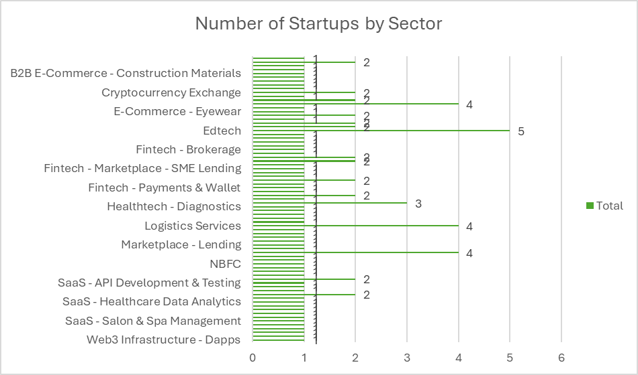

✅ 2. Sector-Wise Share of Startups
Pivot Table:
- Rows: Sector
- Values: Count of Company
Chart Type: Pie Chart
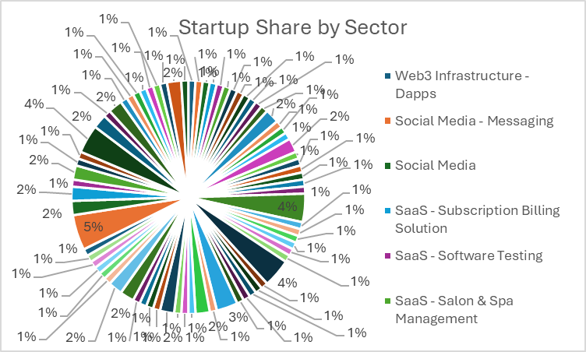

✅ 3. Number of Startups by Location
Pivot Table:
- Rows: Location
- Values: Count of Company
Chart Type: Bar Chart
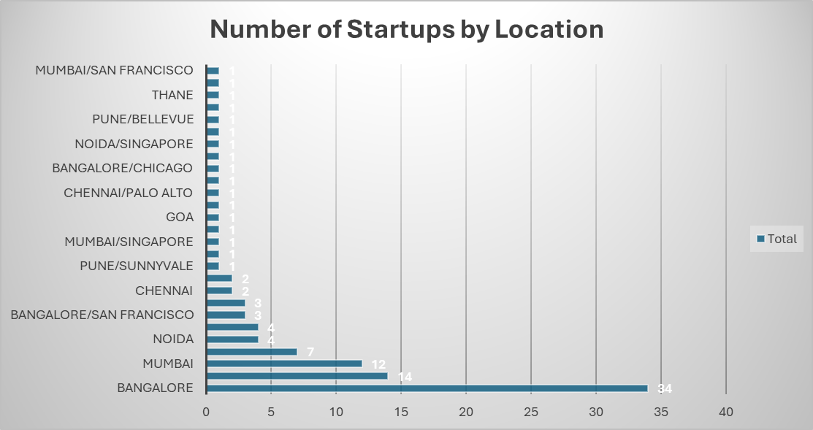

✅ 4. Timeline of Unicorn Entries (Monthly/Yearly)
Helper Column: Converted "Entry" to proper Date
Pivot Table:
- Rows: Entry Date (Grouped by Years and Months)
- Values: Count of Company
Chart Type: Line Chart
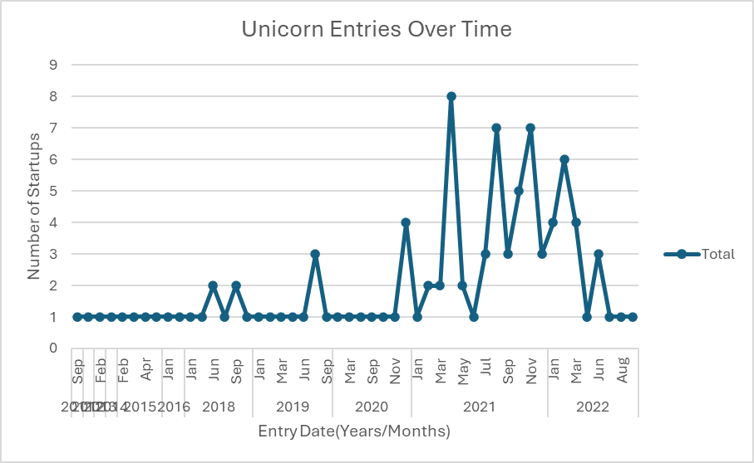

✅ 5. Top 10 Startups by Valuation
Data Sorted by Valuation
Chart Type: Column Chart (Clustered)
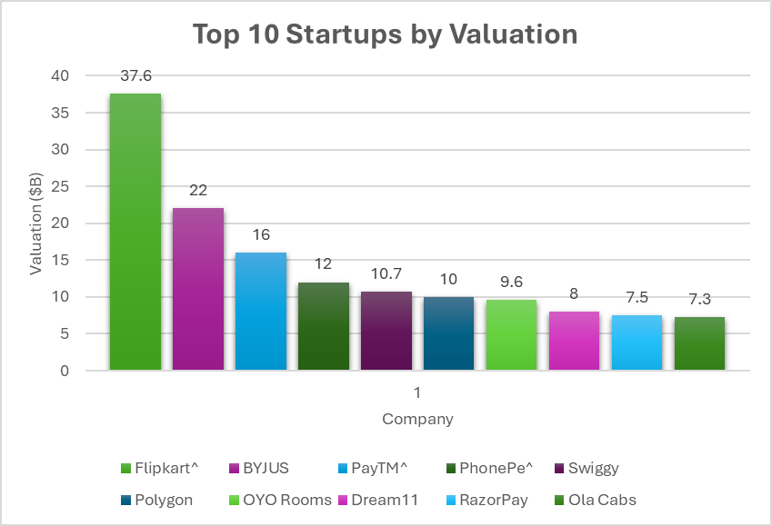

iii. Analysis Results
• Bangalore has the highest number of unicorns.
• Fintech and E-commerce sectors lead in volume and valuation.
• Peak unicorn growth was observed during 2021.
• Top-valued startups include Flipkart, BYJU’S, and Paytm.
• Startup distribution is heavily skewed across a few major cities.

iv. Visualization
Interactive Dashboard Elements:
- Slicers for filtering by Sector, Location
- Timeline Slicer for Entry Date
- Color-coded and titled charts for readability
- Pivot Charts for real-time filter updates

5. Conclusion

The dashboard effectively visualizes key insights about Indian unicorn startups. It reveals patterns in growth, geography, and sector dominance. The interactivity allows users to explore custom queries and view trends dynamically.

6. Future Scope

• Integration with real-time data from web APIs.
• Power BI migration for advanced visuals and DAX queries.
• Adding filters for Investors or Founders.
• Expansion to include pre-unicorn and post-unicorn valuation comparisons.
• Prediction models using ML for upcoming unicorns (based on funding + sector trends).

7. References

- https://www.youtube.com/
- https://www.w3schools.com/
- https://www.datapad.io/blog/excel-interactive-dashboard

8. Links

- https://www.linkedin.com/in/priyanshu-sharma-5a9a97294/

Dashboard

